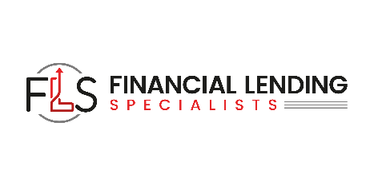

Take advantage of the opportunities in today’s difficult economic environment!

We are a nationally recognized financial company serving our clients financing needs. In these trying times, most banks have a policy to lend money only to those companies that do not really need it. Additionally, most banks are one-dimensional and only do one type of financing. They are not able to provide all the different types of financing small to medium- sized businesses need.
Our expertise and our partnerships with national lenders can provide all your financing needs. If you need to get new equipment, finance your accounts receivable and inventory, raise working capital or acquire a company, we can do it all! If your business has just started or is well established, we have a financing solution for you.

REAL ESTATE FINANCING
We can provide financing for any of your commercial real estate transactions. We work with a network of national direct lenders that have programs that fit all your needs. We can provide commercial real estate loans with loan limits from $250,000 to $10 million or much more.
SECURITIES-BASED LENDING
We offer the nation’s only non-transfer of title securities-based loans. If you have a portfolio of securities, we can set up a line of credit of 70-90% of the value of the portfolio. This line of credit is utilized as a true line of credit and you may borrow as much or as little as you want. You can utilize the money for any purpose with no restrictions.
The loans outlined in this brochure are only a partial list of what can provide. We have a solution for almost all your financial needs.

Financial Lending Specialists
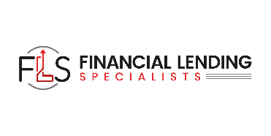

323-285-3721
info@financiallendingspecialists.com
financiallendingspecialists.com
ACCOUNTS RECEIVABLE AND FACTORING
If your customers are taking 60, 90, 100 days or more to pay you, it can be very taxing on your company’s cash flow. We can set up a line of credit where you can get up to an 80% advance on your receivables the day you send an invoice waiting to get paid. When a client pays, you will get the other 20% balance, less any interest charges. We can get you set up in 7 to 10 business days regardless of personal or business credit.

CONSTRUCTION EQUIPMENT FINANCING
We specialize in funding all types of specialty trucks and construction equipment. We work directly with equipment dealers or end users. Our specialty is less than perfect credit.

DEBT RESTRUCTURING
Growing companies enter into loan agreements to pay for equipment needed to expand their businesses. Loans have different maturities, and, in most cases, the companies have built- in equity in the equipment. We will pay off all your lenders and refinance all your equipment into one loan.


BUSINESS ACQUISITION FINANCING
We specialize in providing you with the necessary capital to fund any company you wish to acquire. We can also provide the equity necessary, should there be a cash shortfall between the financing and the cash you are putting into the transaction by leveraging the available assets of the company.

COMMERCIAL BRIDGE LOANS
Often a company is approved for a loan through its bank or financial institution, but the loan doesn’t close for 4-6 months. During that time, we can provide a short-term bridge loan, which will be paid back when the senior loan closes, so your short-term financial needs can be met.

EQUIPMENT LEASING
Leasing is one of the fastest growing ways of acquiring equipment in business today. A growing business often faces the dilemma of limited cash flow and the need to add equipment. Leasing can put the equipment to work for you with real cash flow advantages and without major capital investment. We can finance 100% of equipment cost, include maintenance and installation and every payment is a tax deduction.

UNSECURED BUSINESS LOANS & LINES OF CREDIT

We set you up from start to finish. We establish your corporation if you do not already have one, build your business credit profile, establish your corporate credit and get your company in front of our network of national and regional lenders. You can be approved for a business line of credit for up to $150K whether your business is established for three days or three years.

SBA LOANS
We have been designated as a Preferred Financial Services company by SBA lenders to have loans processed more quickly and efficiently than many others. We can generally get an SBA loan approved in 30 days and funding within 60 to 90 days.

EASY PAY CASH ADVANCE
We are proud to announce one of the easiest and most beneficial ways to get quick cash for your business. This is groundbreaking. Poor credit: no problem, Late payments: no problem. Bank turndowns: no problem. We can lend you an amount equal to your total monthly sales with up to two years to repay. If you take credit cards in your business, you owe it to yourself to check out our easy pay cash advance program.

